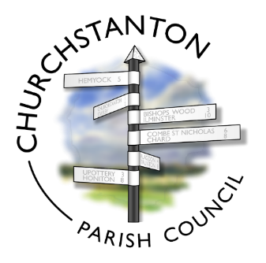

CHURCHSTANTON

ANNUAL PARISH MEETING
You are invited to the Annual Parish Meeting for Churchstanton Parish to be held
on
Wednesday 18th May, 2022 at 7:30 pm
In Churchinford Village Hall
The Annual Parish Meeting is for all electors of Churchstanton Parish to speak about matters relating to them.
Representatives from village clubs and societies, as well as the Parish and District Councils will be invited to give a report about their work in our community.
EVERYONE IS WELCOME
Agenda will be as follows:
- Welcome – Cllr. Ian Firth
- Approval of Minutes of Previous Meeting
- Reports from:
- Churchstanton Parish Council – Cllr. Ian Firth
- Somerset County Councillor – Cllr. Ross Henley
- Blackdown Support Group – Nicki Dowson
- Area of Outstanding Natural Beauty (AONB) – Lisa Turner
- Otterhead Lakes Trust – Nigel Griffiths
- Outdoor Space Management Group (OSMG) – Joe Knowles
- Churchinford & District Community Shop - tbc
- Churchinford Village Hall – Linda Knowles
- Public Paths Liaison Officer – Sarah Henderson
- Hummingbird Residential Home – Stephanie Westlake
- Churchstanton Primary School – Marcus James
- Churchinford Pre-School – Gemma Sparks & Andrea Gibbs
- Charities
- Churchstanton Community Fund – Vote for approval of 2022 grants
- Meeting Close – Cllr. Ian Firth
Please note, this is not a meeting of the council and no council business will be transacted. The Annual Parish Meeting is a statutory meeting that is held for those people who live in our village. Any person on the electoral register of the parish of Churchstanton is entitled to speak at the Parish Meeting.

